Requirement definition

Transitions

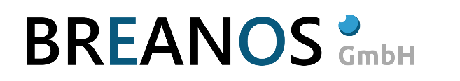

Neutorstraße 13  
5020 Salzburg

AUSTRIA

Tel: +43 (662) 276198-11

Fax: +43 (662) 276198-98

Mail: [office@breanos.com](mailto:office@breanos.com)

|  |  |
| --- | --- |
| File | Requirements definition Transitions.docx |
| Date | 17.08.2018 |

Table of contents

1 Change history 3

2 Requirement definition 4

2.1 Introduction 4

2.2 Scope 4

2.2.1 Let’s start with Transitions in more detail 5

2.2.2 Access to runtime variables 5

2.2.3 How are transitions defined? 5

2.2.4 Extensions which has to be done 6

2.3 Exclusion from scope 6

2.4 Action plan 6

2.5 Effort estimation 6

2.6 Risk assessment 6

2.6.1 Risk short description 6

2.6.1.1 Description 6

2.6.1.2 Consequences 6

2.6.1.3 Avoidance 6

2.6.1.4 Probability 7

2.7 Prerequisites 7

2.8 Acceptance 7

# Change history

|  |  |  |  |
| --- | --- | --- | --- |
| Date | Version | Author | Description |
| 14.08.2018 | 0.1 | EBE | Initial version |
| 16.08.2018 | 0.2 | EBE | Extended effort estimation and risk management. |
| 17.8.2018 | 0.3 | EBE | Added Transition to other BIFs to the document. |

# Requirement definition

## Introduction

The Wexflow Workflow has to be extended to our needs. The Wexflow Workflow has been taken as a working base for the Breanos Workflow and was renamed to BIF Engine. BIF stands for **B**reanos **I**ndustrial Work**f**low.

In this document Transitions are described in more detail.

## Scope

The scope of this document is to clarify all questions regarding the BIF Engine Transitions. First of all, all functionality which has to be added to the BIF Workflow Engine are described in the first section. Second a short test demo scenario is described which the BIF Engine has to work with.

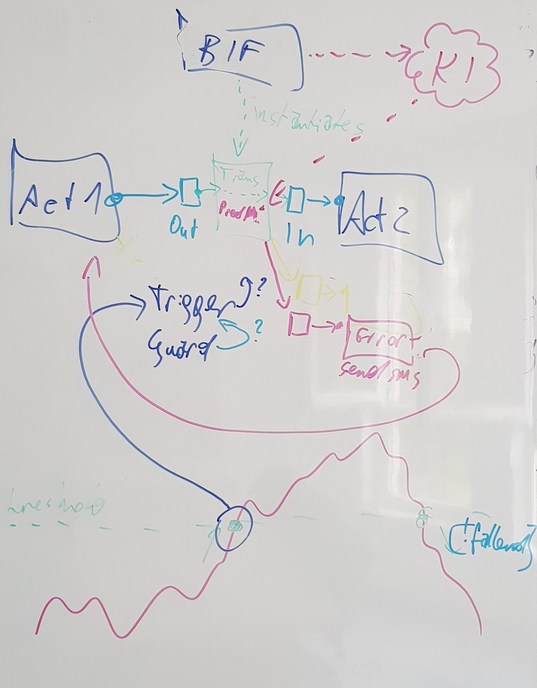

Figure 1 - Initial idea

### Let’s start with Transitions in more detail

A transition links two Activities together. Every transition can have a condition. A condition is a boolean expression which is evaluated by the engine. There can be an unlimited number of transitions from one Activity to another, depending on the computer resources. The evaluation happens from left to right in short circuit evaluation order. That means the first matching transition gets executed. The evaluation order can’t be changed, and the transitions are stored in the creation order. Additional to the boolean condition, there should also be the possibility to define a trigger activity which gets fired once the transition is reached.

### Access to runtime variables

The BIF Engine in his final version should also be able to access global variables, which are defined in the runtime environment. There should be no limitations which data types are used inside the runtime environment.

### How are transitions defined?

Here is an example Workflow with 3 Transitions defined in it:

<Workflow xmlns="urn:wexflow-schema" id="1" name="Workflow_Test" description="Workflow_Test_Description">

<Settings>

<Setting name="launchType" value="trigger" /> <!-- startup|trigger|periodic -->

<Setting name="enabled" value="true" /> <!-- true|false -->

</Settings>

<Activities>

<Activity id="1" name="Trace" description="Trace" enabled="true">

<Setting name="Message" value="Hello World!" />

</Activity>

<Activity id="2" name="WorkflowInvoker" description="WorkflowInvoker..." enabled="true">

<Setting name="WexflowXMLPath" value="C:\\Wexflow\\Wexflow.xml" />

<Setting name="StartWorkflowIndex" value="1" />

</Activity>

<Activity id="3" name="Delay" description="Delay" enabled="true">

<Setting name="Value" value="10000" />

</Activity>

<Activity id="4" name="Finish" description="Finish" enabled="true">

</Activity>

</Activities>

<ActivitySetup>

<Activity id="1"><Parent id="-1" /></Activity>

<Activity id="3"><Parent id="1" /></Activity>

<Activity id="4"><Parent id="3" /></Activity>

</ActivitySetup>

</Workflow>

In the demo example every transition in the ActivitySetup has its own id and a parent id which stores the activities parent id. -1 stays for no parent activity or first activity in the sequence.

### Extensions which has to be done

The transition description must be extended to support Trigger Activities, and Conditional Booleans.

* Trigger Activities

Trigger activities are activities which are executed during a transition.

* Conditional (Booleans)

Are Boolean expressions which are evaluated during runtime.

### BIFs called via Transitions

A BIF can also be executed via a Workflow activity. This functionality is already build in into the BIF Engine and can be invoked via the WorkflowInvoker activity.

## Exclusion from scope

The description of the State Machine requirements is in a separate document.

## Action plan

First define all missing features which has to be implemented and finish this document.

Plan all Tasks in the Story board.

## Effort estimation

The implementation effort is estimated in the project backlog, which can be accessed under:

<http://bre-tfs02:8080/tfs/Daipan/PM%20Daipan/_backlogs/TaskBoard/Iteration%206?_a=requirements>

|  |  |
| --- | --- |
| Task | Hours |
| Extension of input file | 8 |
| Global Variables | 24 |
| Conditions | 10 |
| Trigger activity | 16 |
| Total | **58** |

## Risk assessment

### Risk short description

#### Description

Should be a standard task with minimal risk.

#### Consequences

BIF Engine gets not extended with the transitions.

#### Avoidance

Clarify all questions at the beginning.

#### Probability

Very low.

## Prerequisites

A working BIF Engine implementation with extended transitions.

## Acceptance

Transitions with the new syntax should look like this and execute.

<ActivitySetup>

<Activity id="1"><Parent id="-1" Condition=”x < y” TransitionActivityId=”1”/></Activity>

<Activity id="3"><Parent id="1" Condition=”x == 1” TransitionActivityId=”2”/></Activity>

<Activity id="4"><Parent id="3" Condition=”x > 1” TransitionActivityId=”3”/></Activity>

</ActivitySetup>